Chapter 8 Homework (Forms) - Web Development Technologies

In your html-css\homework\ch08 Homework folder. Create a webpage named music-survey.html and a css file named music-styles.css. Create a music survey form similar to the following picture:
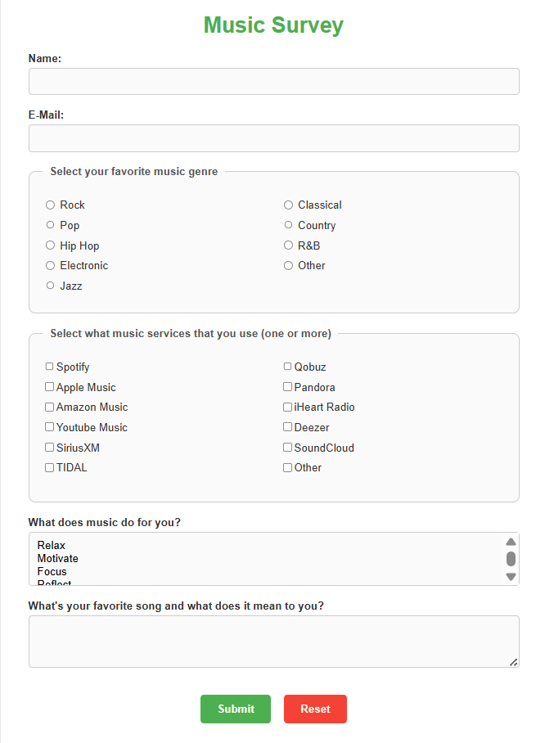

Include the following form controls:
- Use Label elements to provide improved accessibility where appropriate
- Text box for a person's name
- E-mail address input form control for the e-mail address
- A radio button group with at least three choices
- A check box group with at least three choices
- A select box that initially shows three items but contains at least four items
- A scrolling text box that is 60 characters wide and 3 rows high
- A submit button
- A reset button
Use the fieldset and legend elements as shown in the picture to configure the display of form areas with radio buttons and checkboxes
Use a CSS to configure the display of your form.
Place your name and e-mail address at the bottom of the page

